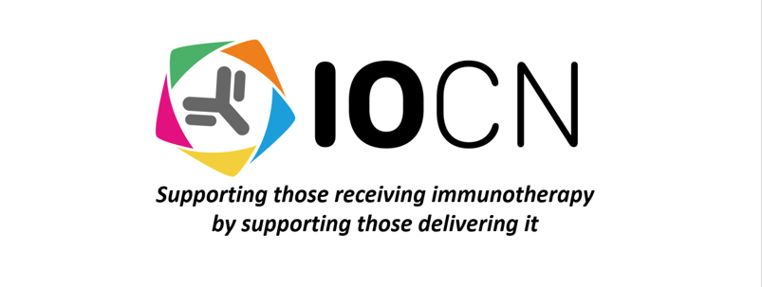
THE IMMUNO-ONCOLOGY CLINICAL NETWORK (IOCN) TERMS OF REFERENCE:

Introduction:

The Immuno-Oncology Clinical Network (IOCN) mission is:

- To support health care professionals delivering immuno-oncology therapies to improve patient care through clinical support, education, service development and governance.
- To promote and support research or any activities that will progress knowledge and understanding of immuno-oncology treatments and the associated side effects.

The IOCN supports healthcare professionals through 5 pillars: Clinical Support, Research and Analysis, Education and Training, Policy and Governance and Service Development.

Scope and Purpose of the IOCN:

The IOCN applied for charitable status in England and Wales in Spring 2023. A Board of Trustees for the IOCN acting as Corporate Trustee for the Charitable Funds has been established to govern and direct the Charity to ensure it is carrying out it’s purpose for public benefit. It is the duty of the Charity Trustees to act in the Charity’s best interest, manage the Charity’s resources responsibly and act with reasonable care and ensure the Charity is complying with the Charity’s governing document and is accountable in accordance with the law.

Meetings of the Board of Trustees:

The Board of Trustees will schedule meetings as decided by the board. There will be a minimum of four meetings per year and any Trustee may call a meeting. The minimum number of Charitable Trustees is 5 and there is no maximum. The board includes a Chair of Trustees, Deputy Chair of Trustees, Secretary and Treasurer. The quorum is 4 Trustees for a meeting of the Board. The Charity Trustees may designate any of their meetings as a general meeting of members of the Charity for the purpose of discharging business, which must by law be discharged by resolution by members of the Charity.

Membership:

The IOCN has two tiers of membership - voting and non-voting (associate). It is the role of the Board of Trustees to govern the membership admission process, duty of members, transfer or termination of membership in accordance with the Charity’s governing document.

Voting membership is open to:

- Any healthcare professional or professional registered with a regulatory body, over the age of 18 years old, involved in delivering and supporting patients who are receiving immuno-oncology treatments and
- Supports the aims and objects of the IOCN and is willing to contribute to decision making within the IOCN and
- Is invited by board of trustees or is the chair or an appointed member of a sub-interest group of the IOCN

Associate membership is open to:

- Any healthcare professional or professional registered with a regulatory body, over the age of 18 years old, involved in delivering and supporting patients who are receiving immuno- oncology treatments. This includes any healthcare professionals involved in the management of immunotherapy toxicities or
- any organisation (whether corporate or unincorporated) whose activities are concerned with matters related to the objects of the IOCN and which nominates an individual to represent the organisation for the purposes of any decisions by members of the IOCN or
- Patient or lay representatives may be explicitly invited to join as a member of the IOCN with approval of the trustees.

Expertise:

The IOCN has specified that there must be expert oncological representation within the Board of Trustees. The Specialist Interest Subgroup Committees within the IOCN contain members with expert experience relevant to the specific interest and specialty of the committee.

Monitoring Effectiveness:

The IOCN strives to constantly improve its performance in line with its charitable aims and objectives. The IOCN Executive Committee provides a performance report and update of its achievements to the Board of Trustees at each Trustee meeting.

Review and Governance:

The IOCN Board of Trustees undertakes a review its Terms of Reference and Constitution document annually.

