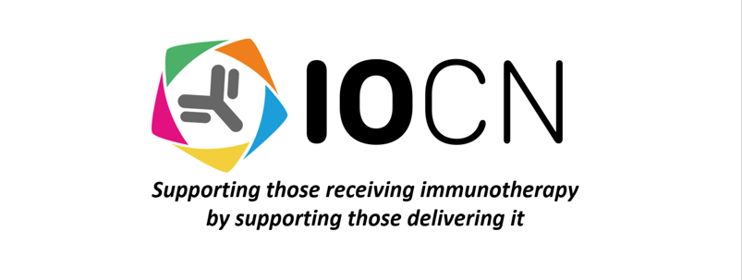
IOCN MEMBERSHIP POLICY

Introduction:

This policy clarifies the membership subtypes of the IOCN. The Immuno-Oncology Clinical Network has a two-tier form of membership; voting members and associate (non- voting) members.

Voting membership

Voting members can participate in the IOCN committee and general meetings. They are also entitled to vote on amending the Charity’s constitution as well as the amalgamation or dissolution of the charity.

Eligibility of voting members:
Membership of the IOCN is open to:
- Any healthcare professional or professional (registered with a regulatory body) over the
age of 18 years old involved in delivering and supporting patients who are receiving
immuno-oncology treatments and
- Supports the aims and objects of the IOCN and is willing to contribute to decision making within the IOCN and
- Is invited by board of trustees or is the chair or an appointed member of a sub-interest
group of the IOCN

Admission procedure for new voting members:
The board of trustees:
- Requires an application of membership to be completed either via the IOCN website www.ioclinicalnetwork.co.uk or completed membership application form to be completed and emailed to the ioclinicalnetwork@outlook.com

- shall, if they approve an application for membership, notify the applicant of their decision within 60 days;

- The IOCN may refuse an application for membership if they believe that it is in the best interests of the IOCN to do so;

- Shall, if they decide to refuse an application for membership, give the applicant their reasons for doing so, within 30 days of the decision being taken, and give the applicant the opportunity to appeal against the refusal;

- Shall give fair consideration to any such appeal, and shall inform the applicant of their decision, but any decision to confirm refusal of the application for membership shall be final.

Membership application:

The IOCN will not ask for any more information on the member than required. The membership application will be reviewed by the Executive Board to ensure that the information required for an application of membership is appropriate and this will be reviewed regularly.

Membership agreement – reporting adverse events:

As part of its role supporting healthcare professionals the IOCN provides support, guidance and advice on the management of immunotherapy toxicities and adverse events. In order to ensure that members are reporting these adverse events to the Medicines and Healthcare products Regulatory Agency via the yellow card scheme the IOCN will ask members to agree to adverse event reporting in the membership agreement.

Transfer of membership:
Membership of the IOCN cannot be transferred to anyone else (except in the case of an individual representing an organization). In this circumstance transfer of the representative does not take effect until the IOCN has received written notification.

Duty of members:
It is the duty of each member of the IOCN to exercise his, her or its powers as a member of the IOCN in the way he or she or it decides in good faith would be most likely to further the purposes of the IOCN. Members may be required to vote at committee meetings and at general meetings of the IOCN.

Duration of membership.

The planned duration of membership to the IOCN is 12 months when the member will be invited to renew their membership.

Termination of membership
- Membership of the IOCN comes to an end if:
- the member sends a notice of resignation to the IOCN or
- the member dies or the organisation no longer exists
- the member exhibits unprofessional behaviour which is deemed unacceptable by the charity trustees
- the charity trustees decide through passing a resolution that it is in the best interests of the IOCN that the member should be removed from membership,
- when any sum of money owed to the IOCN by the member is not paid in full within 30 days
- the planned duration of membership (12 months) ends and the individual or organisation does not wish to renew their membership

- Before any decision taken by the charity trustees to remove an individual or organisation from membership of the IOCN they must:
- inform the member of the reasons why it is proposed to remove them from membership;
- give the member at least 21 clear days’ notice in which to make representations to the charity trustees as to why they should not be removed from membership;
- at a duly constituted meeting of the charity trustees, consider whether or not the member should be removed from membership;
- consider at that meeting any written representations which the member makes as to why the member should not be removed.

Membership fees:
The IOCN may require members to pay reasonable membership fees to the IOCN. The trustees may establish different categories of members with different level of subscriptions

Associate (non-voting) membership:

In additional to formal voting membership the IOCN will have associate membership. Associate members are not entitled to vote on amending the Charity’s constitution or the amalgamation or dissolution of the charity.

Eligibility of associate members:
Associate membership of the IOCN is open to:
- Any healthcare professional or professional (registered with a regulatory body) over the age of 18 years old involved in delivering and supporting patients who are receiving immuno- oncology treatments. This includes any healthcare professionals involved in the management of immunotherapy toxicities

- Any organisation (whether corporate or unincorporated) whose activities are concerned with matters related to the objects of the IOCN and which nominates an individual to represent the organisation for the purposes of any decisions by members of the IOCN.

- Patient or lay representatives may be explicitly invited to join as a member of the IOCN with approval of the trustees

Admission procedure for non- voting members:
- Requires an application of membership to be completed either via the IOCN website www.ioclinicalnetwork.co.uk or completed membership application form to be completed and emailed to the ioclinicalnetwork@outlook.com

- The IOCN may refuse an application for membership if they believe that it is in the best interests of the IOCN to do so;

- Shall, if they decide to refuse an application for membership, give the applicant their reasons for doing so, within 30 days of the decision being taken, and give the applicant the opportunity to appeal against the refusal;

- Shall give fair consideration to any such appeal, and shall inform the applicant of their decision, but any decision to confirm refusal of the application for membership shall be final.

Membership application:

The IOCN will not ask for any more information on the member than required. The membership application will be reviewed by the Executive Board to ensure that the information required for an application of membership is appropriate and this will be reviewed regularly.

Membership agreement – reporting adverse events:

As part of its role supporting healthcare professionals the IOCN provides support, guidance and advice on the management of immunotherapy toxicities and adverse events. In order to ensure that all members are reporting these adverse events to the Medicines and Healthcare products Regulatory Agency via the yellow card scheme the IOCN will ask all members to agree to adverse event reporting in the membership agreement.

Transfer of membership:
Membership of the IOCN cannot be transferred to anyone else (except in the case of an individual representing an organization). In this circumstance transfer of the representative does not take effect until the IOCN has received written notification.

Duty of members:
It is the duty of each associate member to support the aims and objects of the IOCN. Associate members do not have power to vote at general meetings or AGMs.

Duration of membership.

The planned duration of associate membership to the IOCN is 12 months when the member will be invited to renew their membership.

Termination of membership
- Membership of the IOCN comes to an end if:
- the member sends a notice of resignation to the IOCN or
- the member dies or the organisation no longer exists
- the member exhibits unprofessional behaviour which is deemed unacceptable by the charity trustees
- the charity trustees decide through passing a resolution that it is in the best interests of the IOCN that the member should be removed from membership,
- when any sum of money owed to the IOCN by the member is not paid in full within 30 days
- the planned duration of membership ends and the individual or organisation does not wish to renew their membership

- Before any decision taken by the charity trustees to remove an individual or organisation from membership of the IOCN they must:
- inform the member of the reasons why it is proposed to remove them from membership;
- give the member at least 21 clear days’ notice in which to make representations to the charity trustees as to why they should not be removed from membership;
- a duly constituted meeting of the charity trustees, consider whether or not the member should be removed from membership;
- consider at that meeting any written representations which the member makes as to why the member should not be removed.

Membership fees:
The IOCN may require members to pay reasonable membership fees to the IOCN. The trustees may establish different categories of members with different level of subscriptions

