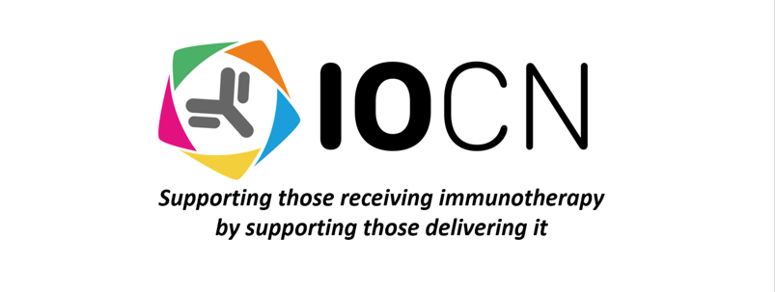
IOCN CRITERIA FOR RESEARCH SELECTION POLICY:

Introduction:

The Immuno-Oncology Clinical Network (IOCN) is committed to furthering the knowledge of immuno-oncology. The IOCN Research Interest Group within the charity will work with the Immuno-Oncology community in the UK to identify areas of unmet need where research would be beneficial to the UK patient population.

There is a defined application process or any endorsed research that will be put forward to the board of trustees for approval. Any endorsed research will have to be made by formal application.

IOCN Research objectives:

The IOCN Research Interest Group will select research and endorse research that aligns with the charity’s objects:

• To support health care professionals delivering immuno-oncology therapies to improve patient care through clinical support, education, service development and governance.

• To promote and support research or any activities that will progress knowledge and understanding of immuno-oncology treatments and the associated side effects.

Eligibility Criteria:

Assessment Criteria:

The IOCN Research Interest Group will assess research on the following criteria:
- Relevance to our research priorities – research in the field of immune-oncology that directly relates to the IOCN Research objects.
- The originality of your ideas and proposal – research that is answering an important and valid research question in the field of immuno-oncology.
- Applicants knowledge of relevant literature and developments in the research area.
- The quality of your experimental design – including the feasibility, practicalities and risks. Show preliminary data if relevant.
- Value for money – to ensure money invested will be spent well in an area of need. The Research Interest Group will ensure accurate budgeting with realistic and justifiable costing.
- Research team – make sure the people you choose have the right expertise. Check if there are other areas they can help with outside of the obvious scientific requirements of the project. For example, do they have a background in public policy that will help you share your findings?
- Applicant– it’s important the funding panel trust their investment in you. Identify your unique strengths and draw on your previous successes.

How the Criteria will be assessed:

IOCN Assessment process:

Research Guidance:

IOCN Research Project Proposal Form

Submit via email to: ioclinicalnetwork@outlook.com

Title
Study Team | Proposing centre:
 | Project lead: | Name:
 |  | Email:
 | Lead clinician: | Name:
 |  | Email:
Project Design
Lay Summary (50 words)
Background
(300 words)
Aims & Objectives
(250 words)
Methods
(300 words)
Feasibility
What is the estimated number of patients on completion?
What is the expected timeframe for completion of the study?
How many participating centres will be needed to reach the required number of patients?
Pilot study (if applicable)
(300 words)
Impact of study
Impact statement
(300 words)
Proposed output from project

Ethics/governance | Are local governance approvals already in place? | YES / NO
Publication/authorship | I confirm that we have read and agree with the NOTCH statement on authorship and open access for all output relating to this project | YES/NO

Guidance to project application:

The IOCN is keen to conduct projects that are well-designed and generate important evidence for the cancer community. The IOCN project application form is designed to maximise the chance of projects being successful if selected. Please note that feedback will be given for all applications, whether successful or not, and we hope these guidance notes are useful. We welcome any pre-submission enquiries although all submissions must be formally submitted via this form during a IOCN proposal call.

Project Design – Outline your proposal using the indicated headings. This section may include details regarding your data collection strategy, statistical plans (including involvement of a statistician if applicable), and the stakeholders in your study design e.g. patient/public involvement, specialist charity or funder engagement, multi-disciplinary input, multi-centre input.

Feasibility – This section is designed to ensure your project is deliverable through the IOCN in a reasonable timeframe. You do not have to complete a pilot study, but it is recommended that some pilot data is generated within your centre or across more than one centre to assess the feasibility of your study plan and data collection tool.

Impact of Study – This section is an opportunity to highlight why this is an important project – for example, is this a rare tumour type with little/no high level evidence, an otherwise under-researched area or an area where real-world data is lacking. You should also propose the impact on clinical care or service delivery. We invite you to briefly outline possible outputs from the project i.e. how the data from the project will be disseminated. For example, you may have a particular journal or conference in mind.

Ethics/clinical governance – Most projects will require clinical governance approval, although the process for this may differ between centres. Note IOCN project proposals should be retrospective studies that do not require Research Ethics Committee (REC) approval or completion of an IRAS form. If you think your project does require formal REC approval, please contact the IOCN team directly to discuss your proposal informally. All IOCN project proposals should have local governance approvals in place by the time the project is submitted.

Publication/authorship – IOCN has a statement on authorship and open access, and only projects where this statement has been agreed will be considered.

